Paso 1: configurar Preparar GCP (APIs + bucket)
Comandos a ejecutar en Cloud Shell (en el navegador en la terminal)
export PROJECT_ID="$(gcloud config get-value project)"
export REGION="us-central1"

gcloud config set project "$PROJECT_ID"
gcloud config set run/region "$REGION"

gcloud services enable \
run.googleapis.com \
cloudbuild.googleapis.com \
artifactregistry.googleapis.com \
storage.googleapis.com

export BUCKET="backoffice-config-$PROJECT_ID"
gsutil mb -l "$REGION" "gs://$BUCKET"
gsutil uniformbucketlevelaccess set on "gs://$BUCKET"

echo "✅ Project: $PROJECT_ID"
echo "✅ Region: $REGION"
echo "✅ Bucket: gs://$BUCKET"

Paso 2: crear el manifiesto:
cat > manifest.json << 'EOF'
{
"env": "dev",
"tenant": "tenantA",
"departments": ["operaciones", "conciliaciones", "finanzas"],
"modules": [
{
"id": "onboarding",
"department": "operaciones",
"type": "mf",
"routeBase": "/onboarding",
"remoteEntryUrl": "https://REPLACE_WITH_MF_HOME_URL/remoteEntry.js",
"moduleName": "module_onboarding",
"exposedModule": "./Routes",
"rolesAllowed": ["support-onboarding"]
},
{
"id": "legacy-kcms",
"department": "conciliaciones",
"type": "iframe",
"routeBase": "/kcms",
"url": "https://REPLACE_WITH_LEGACY_URL",
"rolesAllowed": ["support-operation"]
},
{
"id": "metabase",
"department": "finanzas",
"type": "embed",
"routeBase": "/metabase",
"url": "https://REPLACE_WITH_METABASE_URL",
"rolesAllowed": ["financial"]
}
]
}
EOF

Ejecutar el comando 1:
gsutil cp manifest.json gs://$BUCKET/dev/tenantA/manifest.json
Ejecutar el comando 2:
gsutil ls gs://$BUCKET/dev/tenantA/
Ejecutar el comando 3:
gsutil iam ch allUsers:objectViewer gs://$BUCKET
Ejecutar el comando 4:
export MANIFEST_URL="https://storage.googleapis.com/$BUCKET/dev/tenantA/manifest.json"
Ejecutar el comando 5:
echo $MANIFEST_URL
Ejecutar el comando 6:
curl -s $MANIFEST_URL | head

Paso 3: Crear los proyectos y configurar el federation native
Paso 1: ejecutar este conjunto de comandos por separados:
Comando 1:
mkdir -p ~/backoffice-lab && cd ~/backoffice-lab
Comando 2:
npm i -g @angular/cli@17
Comando 3:
ng new backoffice-shell --routing --style=scss --skip-git
Comando 4:
ng new backoffice-mf-home --routing --style=scss --skip-git
Qué exactamente haces ahora (en Cloud Shell Terminal)
- En el terminal (pestaña TERMINAL abajo) ejecutas todos los comandos de crear proyectos:
mkdir -p ~/backoffice-lab && cd ~/backoffice-lab
npm i -g @angular/cli@17
ng new backoffice-shell --routing --style=scss --skip-git
ng new backoffice-mf-onboarding --routing --style=scss --skip-git
- Luego instalas Native Federation en ambos (igual en Cloud Shell):
cd ~/backoffice-lab/backoffice-shell
ng add @angular-architects/native-federation --port 4200 --type dynamic-host

cd ~/backoffice-lab/backoffice-mf-onboarding
ng add @angular-architects/native-federation --port 4201 --type remote
- Para probar localmente dentro de Cloud Shell:
- Terminal 1:
cd ~/backoffice-lab/backoffice-mf-onboarding
ng serve --port 4201 --host 0.0.0.0
- Terminal 2:
cd ~/backoffice-lab/backoffice-shell
ng serve --port 4200 --host 0.0.0.0
Y luego entras por Web Preview al puerto 4200.
El --host 0.0.0.0 es importante en Cloud Shell para que el preview pueda acceder al server.

Si sale este error:
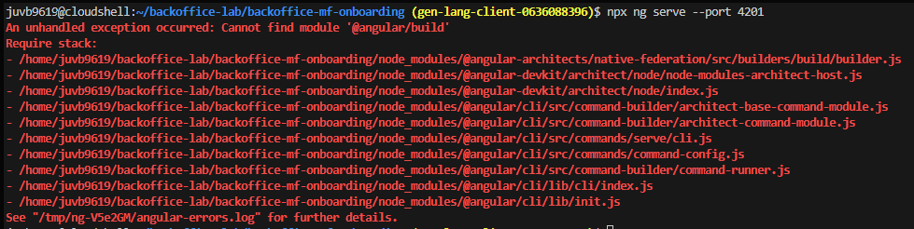

Entonces se ejecutan estos pasos:
Comando 1:
cd ~/backoffice-lab/backoffice-mf-onboarding
Comando 2:
node -p "require('./package.json').dependencies['@angular/core'] || require('./package.json').devDependencies['@angular/core']"
Comando 3:
rm -rf node_modules package-lock.json
Comando 4:
npm install

# baja la lib a la línea compatible con Angular 17.1
Comando 5:
npm i -D @angular-architects/native-federation@17.1.4
Comando 6:
grep -n "@angular/build" angular.json || true
Comando 7:
sed -i 's/@angular\/build/@angular-devkit\/build-angular/g' angular.json
Comando 8:
npx ng serve --port 4201

Aplica lo mismo para el otro proyecto pero se ejecuta al final en un puerto diferente.

